**Wireshark Lab 4 - IP**

IT 520-A – Enterprise Infrastructure & Networks

Moudie Alhousainan

1. What is the IP address of your computer?

IP 10.8.43.16

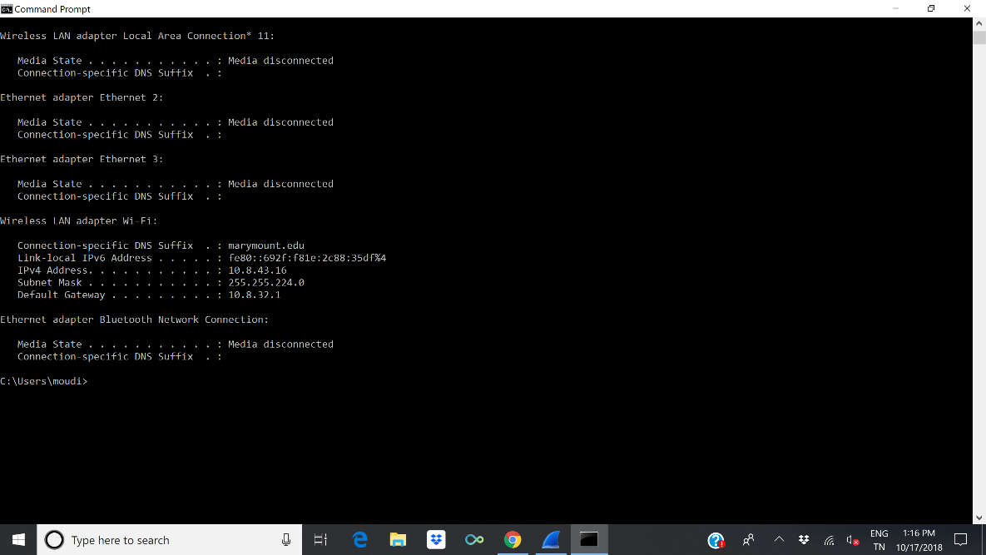

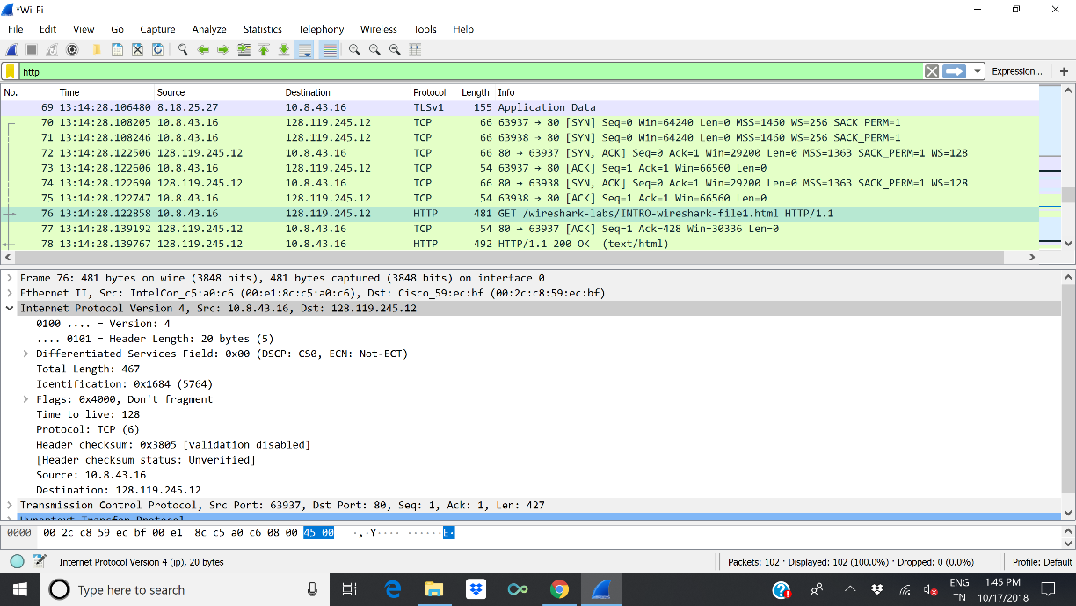





1. What is the total length of the datagram?

Total length = 467 byte

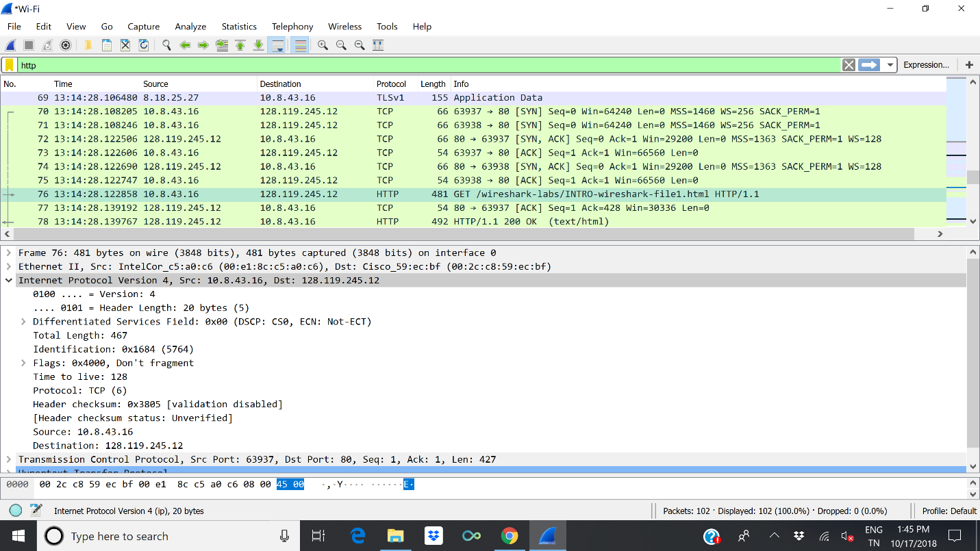

1. Has this IP datagram been fragmented?

No



1. How many bytes are in the IP header?

IP header = 20 byte



1. How many bytes are in the payload of the IP datagram? Explain how you determined the number of payload bytes.

The payload = Total length – the IP header length

447 byte = 467 byte - 20 byte

